NCRN 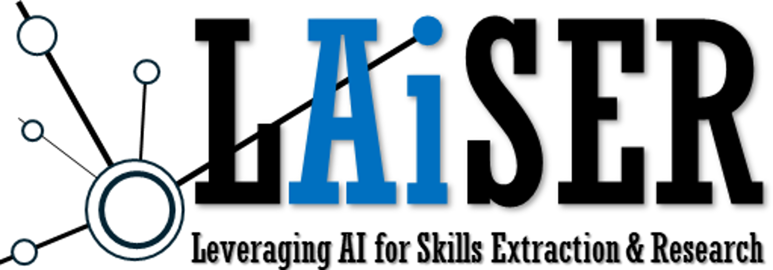

*Enduring skills, a discussion on the nature of skills in an AI world.*

Skills are a critical topic of discussion in education and workforce policy, and many members of the Non-degree Credentials Research Network have dedicated their careers to building a world where skills replace credentials as the currency of the labor market. However, we have been trying to apply 21st century techniques to a 20th century understanding of skills, which has created confusion and a variety of competing projects vying to become the “sole source of truth” on skills and their relationship with labor market outcomes. Yet, none of these projects have achieved widespread recognition or adoption throughout the labor market, and governments around the world remain wedded to aging taxonomies that rely on expert judgment to classify work and learning.

We convene this meeting of researchers and stakeholders who create or use data on skills on the eve of the Non-degree Credentials Research Network’s 2025 Spring Meeting to discuss the foundations of what skills are and how we can effectively identify and assess those skills. We believe that time is of the essence in holding this conversation as AI rapidly evolves in unpredictable directions. Working together as a community to collectively identify needed research and development opportunities will ensure that advances in technology benefit all stakeholders and move us faster in the direction of a world where everyone can benefit from interoperable data systems and cutting-edge research methods.

**Event Details**

|  |  |  |  |
| --- | --- | --- | --- |
| *Time:* | *May 27, 2025 3-5pm EDT* | *Location:* | *Ric and Dawn Duquès Hall*  *1918 F St NW, Rm. 259*  *Washington, DC 20052* |

|  |  |  |
| --- | --- | --- |
| **Agenda** | | |
| Welcome | Introduction of participants and motivation for the workshop | *3-3:10pm* |
| Understanding Skills | What is a skill? | *3:10-4:00pm* |
| What data describes skill? |
| Adapting and Certifying Skills | How can we assess skills using data? | *4:00-4:45pm* |
| Are skills durable over time and can we adjust over time? |
| Who should be certifying skills? |
| Closing Remarks | Reflecting on key insights and determining next steps | *4:45-5:00pm* |

*Presented by the Program on Skills, Credentials and Workforce Policy at the GW Institute of Public Policy*

For more information or to request a Zoom link: Mike Sanders, PSCWP@GWU.edu